URL: https://adityabirlahospital.com/doctors/sexologist-in-pune
Home / Doctors / Sexologist

Best Sexologists in Pune
A sexologist is a medical professional who specializes in sexual health, offering expert care for individuals or couples facing challenges related to sexual function, sexual health education, and emotional well-being. If you’re looking for a sexologist in Pune, our experienced specialists provide discreet and professional care tailored to your needs.

Our Team of Sexologists in Pune
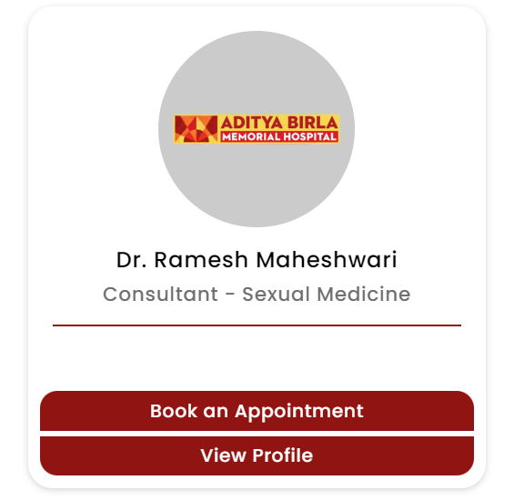
At our hospital in Pune, we have some of the best sexologists in Pune, offering compassionate and personalized care for a wide range of sexual health concerns. Whether you’re facing issues like erectile dysfunction, low libido, or emotional difficulties related to intimacy, our top sexologists are here to help.

Our Sexologists Treat Many Conditions, Including:

How Do I Find the Best Sexologist Near Me in Pune?
If you’re searching for a sexologist near me or the best sexologist doctor in Pune, our hospital offers expert treatment in a comfortable and confidential environment. We understand that addressing sexual health issues can be sensitive, and we are dedicated to providing a compassionate approach to help you navigate these challenges.
Our hospital is easily accessible from nearby areas, so finding a sexologist doctor in Pune who meets your needs is more convenient.
Nearby Locations:
Hinjewadi, Wakad, Baner, Aundh, Pimple Saudagar, Bhosari, Ravet, Chinchwad Gaon, Tathawade and Nigdi.
